## Web Developer – Interview Requirements

As part of your interview, you are requested to develop a small web application.

This web app should be able to show Drinks results using the search.

You are required to develop this web app with **React** (preferred) or **Angular** or other library/ framework (less preferred) and the website should answer the following requirements:

You need to use this API provider in your web app: <https://www.thecocktaildb.com/api.php>

1. **Drink Finder Page** (See below illustration)
   * At the initial loading of the page, you should render a random drink from the API above
   * user should be able to type a drink name and search it by clicking the search button.
     + Previous search names should be saved and displayed under the search input as a clickable element
     + By clicking on the previous search, it will trigger the search again with the right results.
   * The search result should be displayed at the drinks list window, each drink is a clickable element
     + Each list item will contain: Drink name, category, matching glass icon (at least 3 different icons and default one)
   * User can click on a drink name and the full details of the selected drink will be shown in the correct component (See below illustration)
     + Full details will contain most of the information that returned from the API.
       - Name, Category, Glass, Instructions, Ingredients, date (formatted DD-MM-YYYY) and the image
       - By clicking on the image, it will open the image in a modal
   * User can filter the drinks list results
     + User will be displayed with an input box above the drinks list results.

(Filter by ingredients)

once user focus out the input and there is value inside the input box, the drinks list will be refreshed to display only the drinks that have an ingredient with the entered value.

* User can sort the drink list results of drinks by name (ascending) and date (descending)
  + You should use MUI or Bootstrap as your style framework
    - You need to use the GRID system



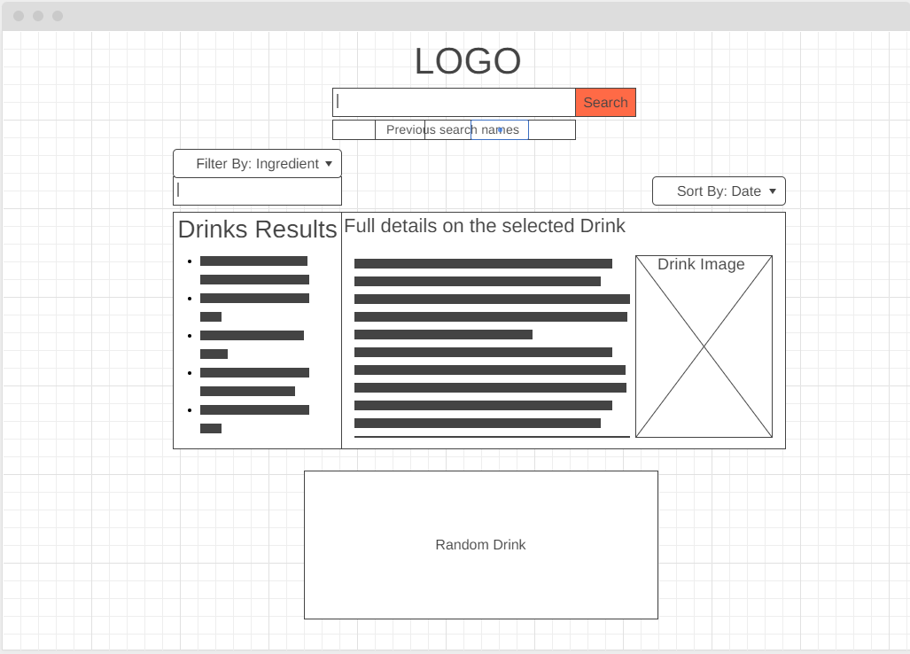

1. **General Requirements**

* Keep your code clean and readable.
* Break your web application into components and containers
* Make sure you design your **application state** right, choose what to put in local state and what in the application state

1. **Technologies** 
   * + **Make sure you have node.js installed on your computer, you can download it from nodejs.org**
     + React/Angular/other
     + You can use the following guidelines how to start your project
     + React - <https://github.com/facebook/create-react-app>

#### Angular - https://angular.io/generated/live-examples/getting-started-v0/stackblitz